Scheduling
Contents:
Credentialing Wiki:…….……………………..…………………………………………………..…….……………………….…3
Appointment Notes:…….……………………………………………………………………………….………………………….6
Ultrasound Scheduling Guide:………….………………………………………..……………………………………………..9
OB Timelines:………………………………….……………………………………………….…………………......................10
Prebuilt Schedule:…………………………….……………..................................................................................14
Customized Schedule:………………………………………………….………………………………………………………….15
Allocated vs Unallocated:…………………………………………….…………………………………………………………..17
Scheduling an Appointment:…………………………………………………….……………………………………………..18
Genetic Screening:…………………………………….……………………………………………………………………………23
What you need to know prior to scheduling:..….………………………………………………………..24
How to document in the Appointment Notes:..………………………………….……………………..24
Scheduling a SEQ:………………………………………………………………………………………………………………….25
Setting Appointments:……………………………………………………………………………………………………………26
Scheduling Procedures:………………………………….………...…………………………………………………………….27
Recalls:…..……………………………………………………..………………………………………………………………………31
Recall Quiz:…………………………………………………………………………………………………………..43
Appointment Search:……………………………………….……………………………………………………………………..44
Canceling Appointments:………………………………….…………………………………………………………………….48
No Shows:………………………………………………………..…………..……………………………………………………….50
Failed Appointments:…………………………………………………….……………………………………………………….52
Wait List:…………………………………………………………………….………………………………………………………..53
Reschedule List (Putting a Patient on the r/s list):………….…………………………………………………………56
Scheduling from the Reschedule List:……………………………………………………………………..59
Finance and Scheduling:……………………………………………………………………..………………………………….62
CNM’s and NP’s:………………………………………………………….…………………………………………………………63

Credentialing Wiki Workflow
http://wiki.whallc.com/Credentialing/ProviderList
You will need to access the Credentialing Wiki when scheduling a patient with a provider who is new to your office. Whether or not the provider is credentialed with the patient’s insurance needs to be verified prior to scheduling. Access the Wiki by clinking on the link above.
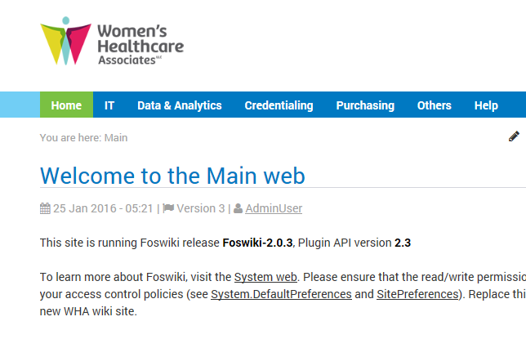
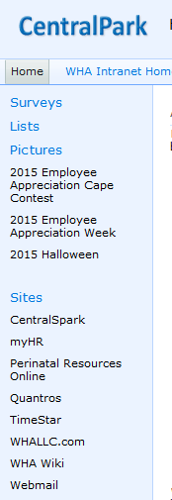
2
1

1. From Central Park, click on ‘WHA Wiki’
2. Click on ‘Credentialing’

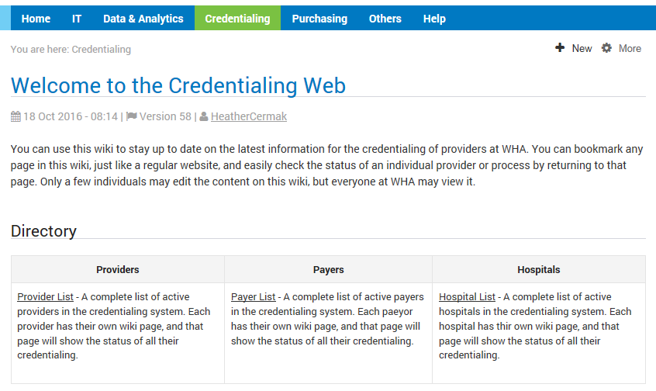
Credentialing Continued
3
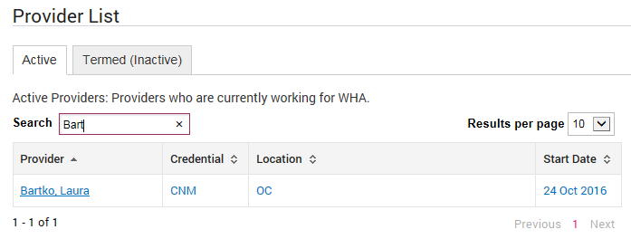
5
4
3. Click on ‘Provider List’
4. Type in the last name of the provider you are searching for (as soon as you start typing, the site will start pulling up the provider’s name)
5. Click on the provider’s name

Credentialing Continued
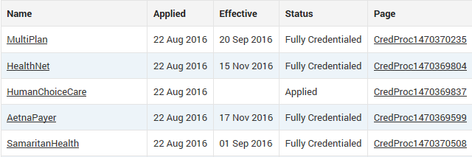
7
6

6. Scroll down to find the type of insurance the patient has. If it says ‘Fully Credentialed’, it is ok to schedule the patient with that provider.
7. If the type of insurance the patient has says ‘Applied’ do not schedule the patient with that provider, even if it is several months out.

Appointment Notes:
All appointment notes should include at minimum:
What the visit is for (if it’s not clear by the appointment type)/Anything else happening today? /Date of last Annual/Mammo (if appointment is for an Annual/Mammo)/Insurance//Initials

OB Check: Any other appointments today?, Insurance//Initials

SEQ 1: Ultrasound Notes: SEQ 1, provider to follow, Insurance//Initials
Ex: SEQ 1, Dr. Smith to follow, BCBC//crs
Lab Notes: SEQ 1, (Provider name) to follow, Insurance//Initials
Ex: SEQ 1, Dr. Smith to follow, BCBC//crs
OB Check Notes: SEQ 1 prior, Insurance//Initials
Ex: SEQ 1 prior, BCBC//crs
SEQ 2: OB Check Notes: SEQ 2 to follow, Insurance//Initials
Lab Notes: SEQ 2, (Provider name) prior, Insurance//Initials
Anatomy: Ultrasound Notes: Anatomy survey, (Provider name) to follow, Insurance//Initials
OB Check Notes: Anatomy survey prior, Insurance//Initials
Postpartum: PP3, Delivered xx/xx/xx, delivery style (vaginal, c-sec) Insurance//Initials Schedule 21-56 days after delivery
PP8, Delivered xx/xx/xx, Anything else happening today (ex: IUD insert), Insurance//Initials
Schedule 8 weeks after delivery. Schedule as an annual.
New Patient Annual: NP, Last annual xx/xx/xx, Patient Portal (to indicate if it was set up) or Pt arriving 20, 30mins early for NP ppwk, Additional notes about records, anything else happening today, Insurance//Initials
Established Annual: Last Annual xx/xx/xx, Anything else happening today? (Ex. Mammo prior or Mammo to follow), Insurance//Initials

Mammogram: Last Mammo xx/xx/xx, has implants or no implants, Anything else happening today? (Ex. Dr. X to follow or Dr. X prior)/pt aware of possible out of pocket expense of $69, Insurance//Initials
*New Patients can only have a mammogram if it is after their first visit with a provider

New Patient Office Visit: NP, Reason for appt, Patient Portal (to indicate if it was set up) or Pt arriving 20, 30mins early for NP ppwk, Additional notes about records, Insurance//Initials
Est Office Visit: Reason for appt, Anything else happening today?, Insurance//Initials
Procedure: Reason for appt, Procedure Rm X booked (if applicable), Insurance//Initials
*If a procedure room is needed, the appointment notes are:
Reason for appt with Provider name, Insurance//Initials
Lab: Reason for appt, Anything else happening today?, Dr. Smith’s pt., Insurance//Initials

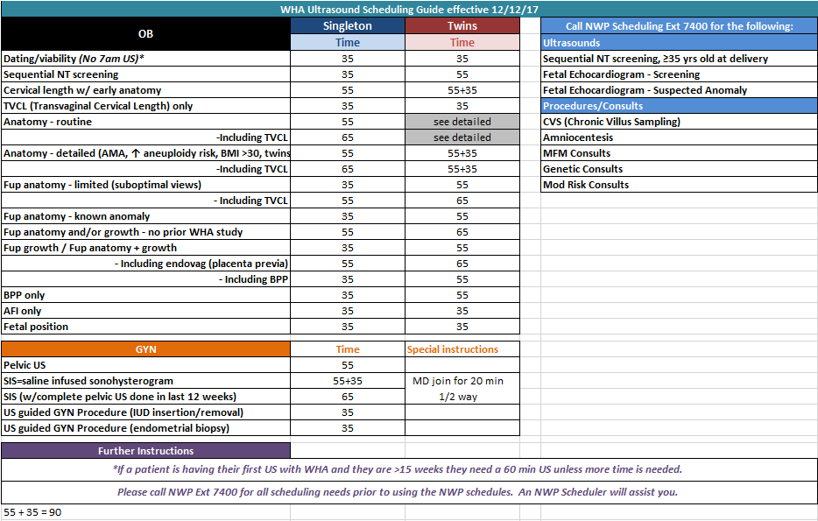

Traditional OB Timeline
NIPT/Harmony after 10.2wks

Traditional OB Timeline

Pathways OB Timeline
24wk Group
16wk Group Possible SEQ 2
36wks OB Check

34wks Group
32wks Group
28wks *OB Check 28wk Labs

10wks PCC Group
4-8wks *MA Intake *Prenatal Labs

20wks *Anatomy Ultrasound *OB Check

11.5-12.6wks OB Workup Possible SEQ 1 or NIPT
Poss

41wks OB Check

40wks OB Check

39wks OB Check

38wks OB Check

Pathways OB Timeline

Scheduling
Opening a Pre-Built Schedule:
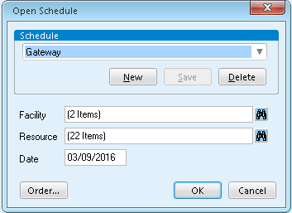
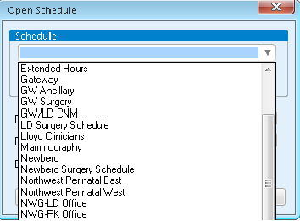
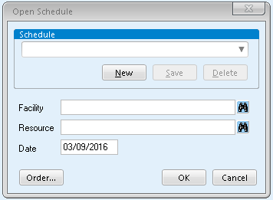
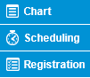
4
3
2
1
1. Click on the schedule icon from the tool bar or from the digital dashboard
2. Click on the drop-down arrow to open the list of pre-built schedules
3. Click on the schedule that you need
4. Click ‘OK’

Opening a Customized Schedule:
1
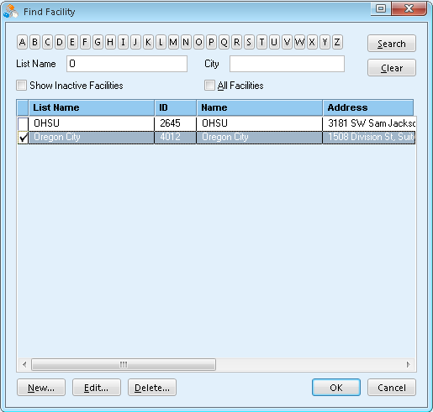
1. Click on the schedule icon from the tool bar or from the digital dashboard
2. Insert the facility that you need by clicking on the binoculars
3. Search for the facility by clicking on the first letter of the clinic name
4. Check-mark the facility that you need
5. Click ‘OK’

4
3
5
2
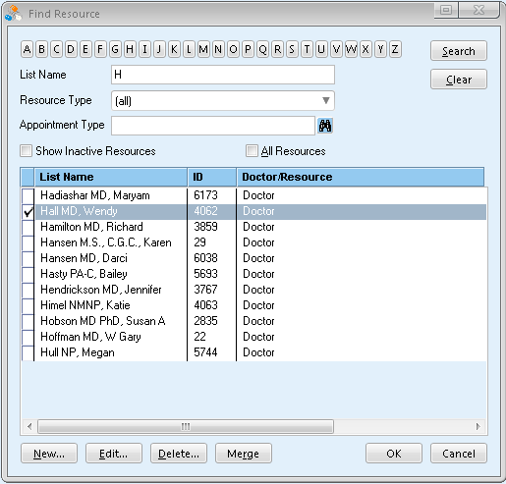
Customized Schedule (Continued)
7
8
6
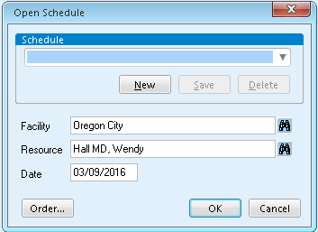
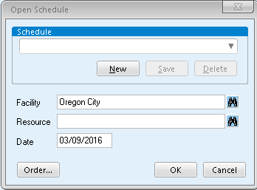
Allocated vs Unallocated:
6. Insert the resource(s) you need by clicking on the binoculars
7. Pick the resource(s) (provider, procedure room, mammo, dexa, ultrasound, etc) by clicking on the first letter of the provider’s last name or clinic where the resource will be at
8. Check-mark the resource(s) that you need
9. Click ‘OK
10. Click ‘OK’

10
9

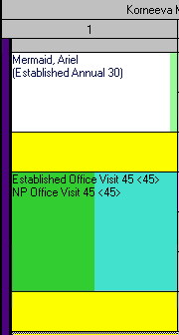

1

2

1. This is an an Allocated spot. When a spot is allocated it specifies what type of an appointment can be scheduled in it. In this example, only an Established Office Visit 45 (45 minute long appointment) or NP (new patient) Office Visit 45 (45 minute long appointment) can be scheduled in this spot.
2. This in an Unallocated spot. It is free to be used however it is needed so long as the times match up. For example, if you need to schedule an Established Office Visit 20 (20 minute long appointment), you need to make sure that the yellow slot is 20 minutes long or that you have enough yellow unallocated spots to equal 20 minutes.

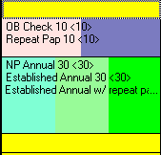
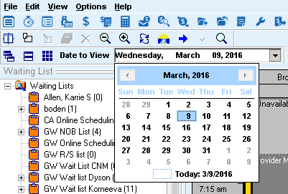
Scheduling an Appointment:
2
1
1. Pick the date that the patient needs to be scheduled for by clicking the drop-down arrow and clicking on the exact date
a. You can change the month by clicking on the left or right arrows or by clicking on the month that is in blue. This will show you each month of the year. Click on the month that you need and then click on the date that is needed
2. Double click on the appointment the chosen appointment

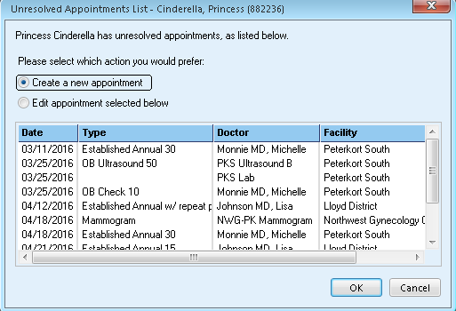
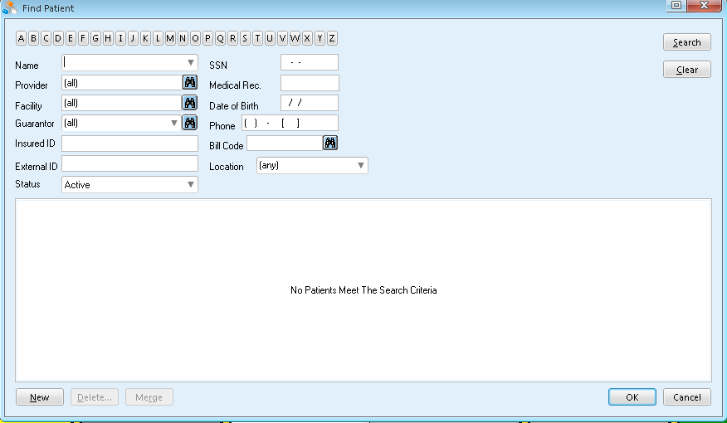
Scheduling an Appointment (Continued)
3. Pick the patient that you need to schedule by clicking the drop-down arrow and then click on the name of the patient to schedule
4. Click ‘OK’
5. Click ‘OK’ (leave the radio dial on ‘Create a new appointment’)

5
3
4

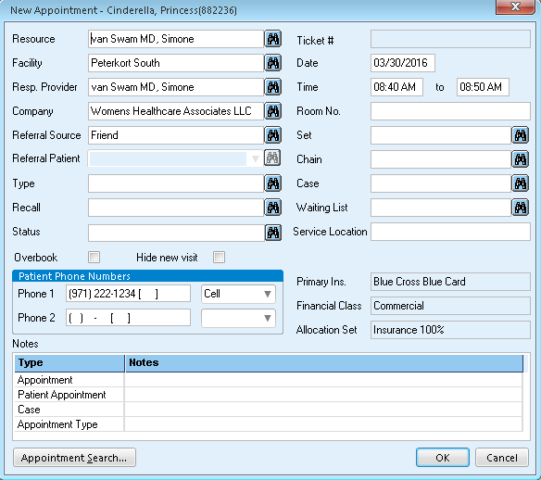
Scheduling an Appointment (Continued)
7
6
8
9
6. If the Responsible Provider is not filled in, make sure to fill it in. In the white box type the first couple of letters of the provider’s last name and then click ‘Tab’ and it will auto-populate or you can find the provider by clicking on the binoculars and search by last name
a. Leave the ‘Resp. Provider blank for an ultrasound and ONLY an ultrasound
7. Put in the ‘Type’ of appointment (ex. Ob 10, Est Annual 30, Procedure 30, etc.) by typing the first couple of letters in the white box and then click ‘Tab’ or by clicking on the binoculars. Pick the appointment type needed and click ‘OK’
8. If you are scheduling a patient for two different appointments in the same day and at the same location, click on the binoculars -> click on the other appointment for the day -> click ‘OK’ to set (link) the two appointments together. This will only work when scheduling the second appointment
9. Double click to add Appointment Notes

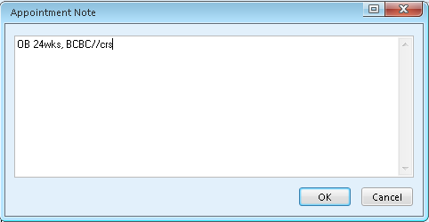
Scheduling an Appointment (Continued)
10

11
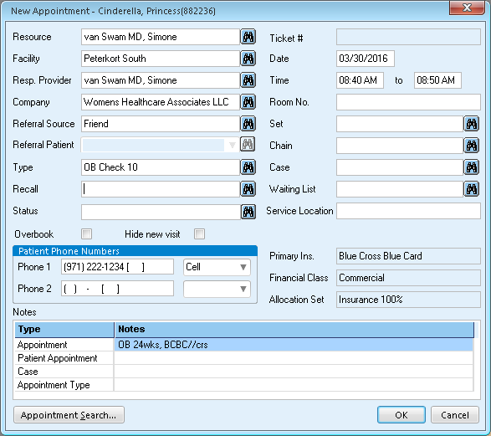

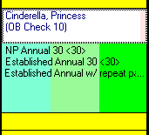
13

12
10. Type in Appointment Notes (see pg. 6 for a list of what notes are needed for each appointment type)
11. Click ‘OK’
12. Click ‘OK’
13. Your appointment is now scheduled

Scheduling (Continued)
Notes: ____________________________________________________________________________________________________________________________________________________________________________________________________________________________________________________________________________________________________________________________________________________________________________________________________________________________________________________________________________________________________________________________________________________________________________________________________________________________________________________________________________________________________________________________________________________________________________________________________________________________________________________________________________________________________________________________________________________________________________________________________________________________________________________________________________________________________________________________________________________________________________________________________________________________________________________________________________________________________________________________________________________________________________________________________________________________________________________________________________________________________________________________________________________________________________________________________________________________________________________________________________________________________________________________________________________________________________________________________________________________________________________________________________________________________________________________________________________________________________________________________________________________________________________________________________________________________________________________________________________________________________________________________________________________________________________________________________________________________________

Genetic Screenings:

 | Non-Invasive Prenatal Test (NIPT) | Sequential Screen (SEQ1 and SEQ2)
Who is the test for? | Low-Risk patients | Higher-Risk patients (as determined by patient’s clinician)
What does it screen for? | Down Syndrome, Trisomy 13, Trisomy 18, and other chromosomal conditions.  Fetal sex determination is also possible. | Down Syndrome and other genetic disorders.
What does the test involve? | A single blood draw. | For SEQ1: Ultrasound and blood draw.  For SEQ2: Blood draw
When can this test be done? | 10.1 weeks gestational age. | SEQ1: 11.3-13.6 (12 weeks is ideal) gestational age.  SEQ2: 16-18 weeks gestational age.

Notes: ______________________________________________________________________________________________________________________________________________________________________________________________________________________________________________________________________________________________________________________________________________________________________________________________________________________________________________________________________________________________________________________________________________________________________________________________

Scheduling/Genetic Screenings (Continued)
For both Sequential Screening and NIPT Testing:

What you need to know prior to scheduling:
- What is patient’s date of birth?
  - If she is AMA (35 years or older at the TIME OF DELIVERY) you will need to refer her to Northwest Perinatal for scheduling.
  - If she is Non-AMA (34 years or younger at the TIME OF DELIVERY, and has no genetic history), you can continue to the next question.
- What is her due date? (Use your pregnancy wheel to be sure you are scheduling during the right time frame.)
  - If you are scheduling a NIPT, schedule after patient is 10 weeks 1 day gestational age.
- If you are scheduling a SEQ, schedule between the range of 11.3 and 13.6 weeks gestational age (12 weeks is the optimal time)
  - Patient will be given an appointment scheduling ticket for the date of the next blood draw after the first screen.

How to document in Appointment Notes:
- For NIPT:
  - NIPT, Insurance//Initials
- For SEQ1:
  - SEQ1, Any other appointments happening same day, Insurance//Initials
- For SEQ2:
  - SEQ2, Any other appointments happening same day, Insurance//Initials



Scheduling a SEQ:
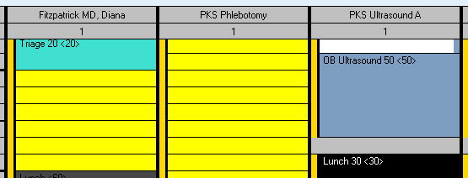
*You will need to schedule an Ultrasound, Phlebotomy, and OB check appointment between 11.3-13.6 weeks. Either open up the schedules needed to do this or create a customized schedule (Facility = your clinic; Resource = Facility ultrasound, facility lab, provider):
1
3
2
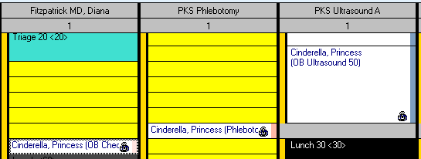
4

5
1. Schedule the ultrasound. See pgs. 13-16 for scheduling instructions if needed – remember do not insert the Responsible Provider for the ultrasound
2. Schedule the lab/phlebotomy appt. See pgs. 13-16 for scheduling instructions if needed – remember to set this appointment with the ultrasound if they are happening at the same location
3. Schedule the Ob Check. See pgs. 13-16 for scheduling instructions if needed – remember to set this appointment with the lab if they are happening at the same location
4. This shows all three appointments schedules. The lock icon in the bottom-right of each appointment indicates that the appointments are set
5. You can check that everything is scheduled correctly in the patient’s registration ‘Appointments Tab’

Setting Appointments:
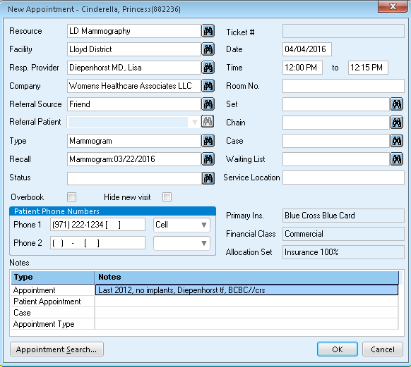

1

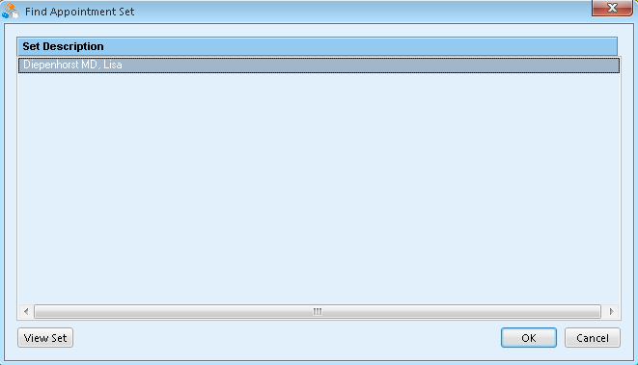
2

3
1. Click the binoculars next to the ‘Set’ field
2. The appointments available to set together will be listed. Highlight the one you want
Only appointments scheduled for the same day will be listed
3. Click ‘OK’

*You will see that the “Set” field is filled in with the Procedure Room info.
*Click “OK”
*Your appointments are now set together.

Scheduling (Continued)

Scheduling Procedures:
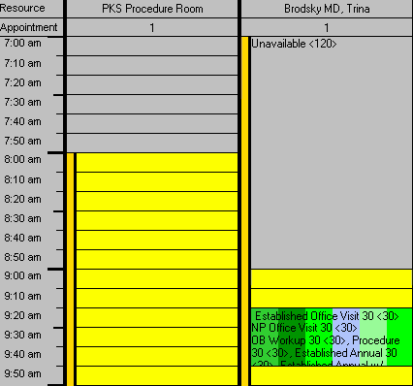
*You will need to schedule the clinician’s time and procedure room’s time. Start by building a custom schedule that includes the clinician and all available procedure rooms.

1

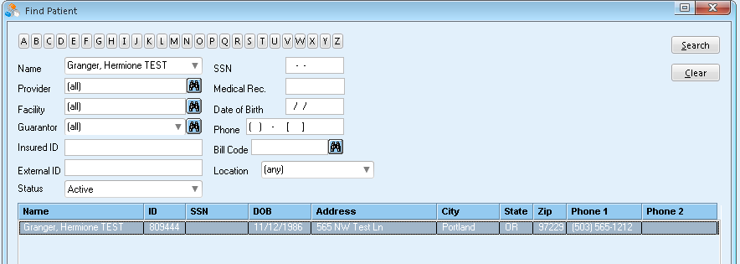
2
3
1. Double click on the Procedure Room time that is 10 minutes prior to the time with the provider (to allow time to set up for the procedure)
2. Choose the correct patient from the drop down menu
3. Double click on the patient’s name or click ‘OK’

Scheduling Procedures (Continued)
*Complete the New Appointment Box
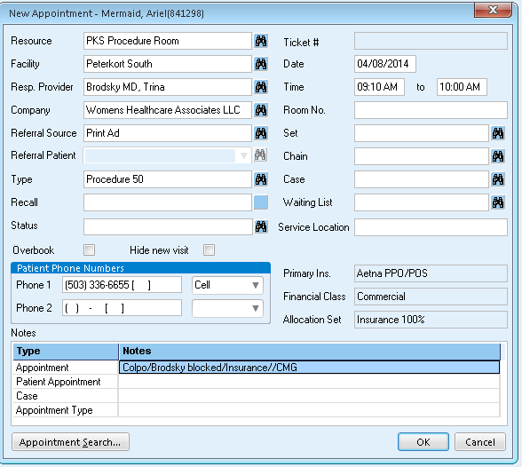
4

5

6

7

4. Fill in the ‘Responsible Provider’
5. Fill in ‘Type’ as ‘Procedure 50’
6. Double click and add appointment notes (Type of Procedure with Provider name, Insurance//Initials)
7. Create/attach a recall for 8 weeks out from the day you make the appointment

Scheduling Procedures (Continued)

8

10
9

8. Double click on the needed appointment time
9. Choose the correct patient from the drop down menu
10. Double click on the patient’s name or click ‘OK’

Scheduling Procedures (Continued)
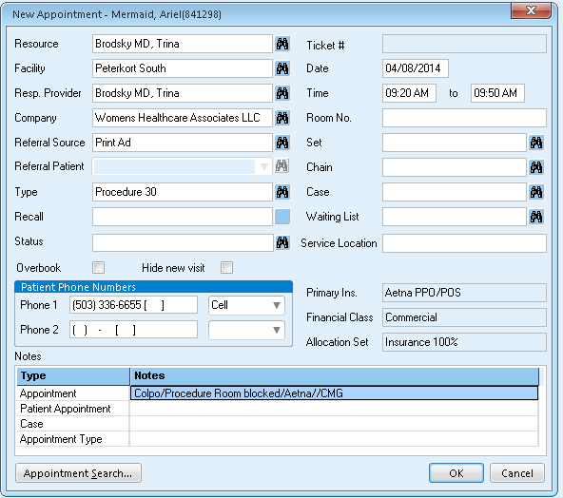

14
12
11

11. Fill in the appointment ‘Type’ (Procedure)
12. Create/attach a recall for 8 weeks out from the day you make the appointment
13. Double click and add appointment notes (Type of Procedure, Procedure Room booked, Insurance//Initials)
14. Set the provider appointment with the procedure room appointment
15. Click ‘OK’

13
15
Recalls
Annual and Mammogram recalls are created to help us remind patients of when they are due for their next annual or mammogram. Generally once they have had their annual and/or mammogram, the Billing department will create a recall for when they are due the following year and the scheduler will just attach that recall when the appointment is made the following year.
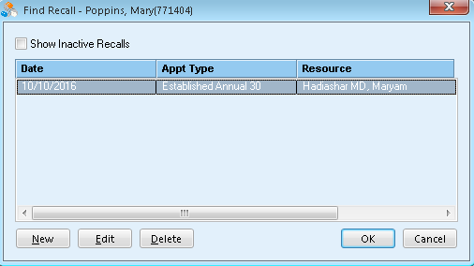
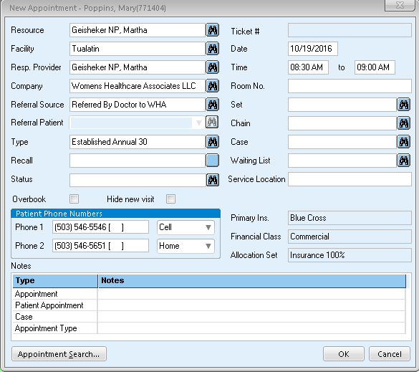
3
2
1

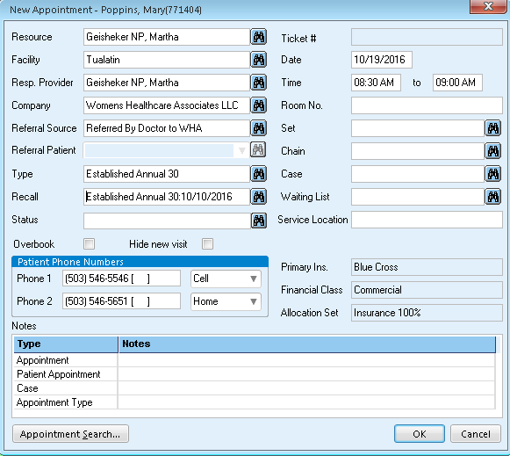

4

1. Click on the blinking binoculars
2. Click on the recall that matches the appointment you are scheduling
3. Click ‘OK’
4. It is now attached to your appointment

If there is no recall created for the particular appointment, then you will need to create one:
-> Future: If the patient is due for her annual/mammogram in the future, create the recall for when she is due.

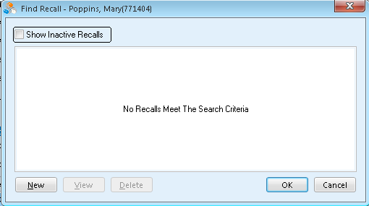
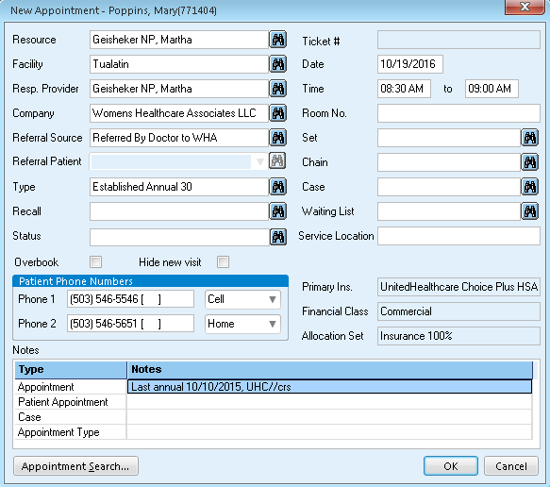
2
1

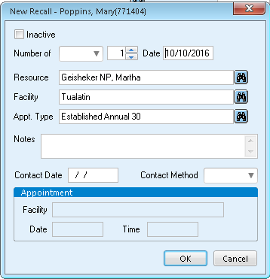
3

4

1. Click on the binoculars
2. Click on ‘New’
3. Type in the date that the patient is due for her annual
4. Click ‘OK’

-> Past: If the patient if due for her annual/mammogram in the past, you will need to create the recall for tomorrow’s date and put in the notes, “pt originally due xx/xx/xxxx”. The system will not let you create a recall for the past.
2
1

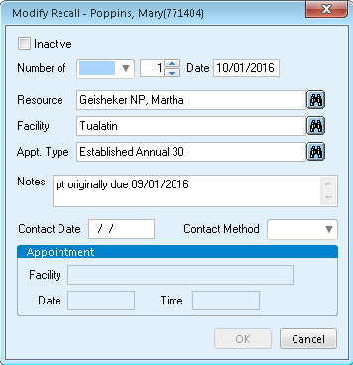
3

4

5
1. Click on the binoculars
2. Click on ‘New’
3. Change ‘Number of’ to ‘Days’ or type in tomorrow’s date
4. Document in the notes when the patient is due for her annual/mammogram with the following format: ‘pt originally due xx/xx/xxxx
5. Click ‘OK’

Procedure Recalls are created to help us keep track of a patient in case she cancels her appointment. Because procedures are more time sensitive appointments, we want to make sure to do our part to get a patient in as soon as we can. If the patient cancels her procedure, the recall is removed prior to canceling the appointment. This allows the recall to still exist in the system and then will be pulled up on a report so that we can follow up with the patient and try to reschedule her appointment. Procedure recalls should be created 8 weeks from the day you are scheduling the patient, not 8 weeks from the date she has her appointment scheduled. Meaning, if I am on the phone with a patient today (09/30/0216) and scheduling her for a colposcopy on 10/10/2016, then I will create the recall to be 8 weeks out from today, not 8 weeks from 10/10/2016. Indicate in the notes of the recall, which procedure the recall is for. The recall needs to be in the appointment on the provider’s schedule and not in the procedure room portion.
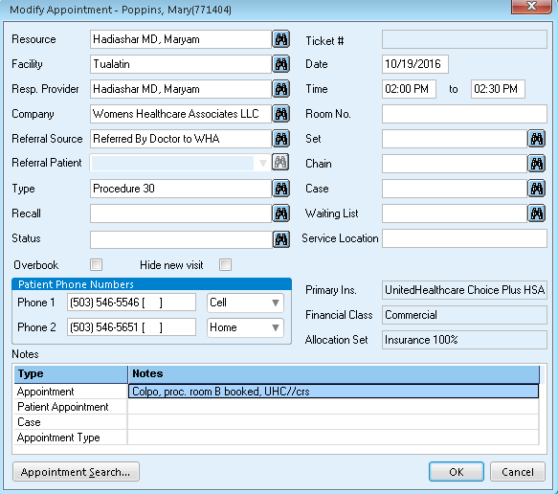
2
1

1. Click on the binoculars
2. Click on ‘New’

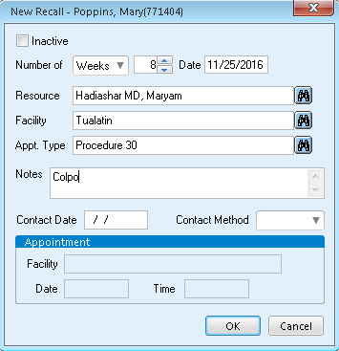
3

4

5

3. Change ‘Number of’ to ‘Weeks’, change the number to 8 (so that the recall is set to be 8 weeks out)
4. Document in the notes what type of Procedure the recall is for. Ex: Colpo
5. Click ‘OK’

Repeat Pap Smears are created according to orders in the chart. When the order is created by the clinical staff or provider, a flag is sent to the Patient Services Proxy. Generally, PSR’s create the recall for a repeat pap smear. Create the recall, complete the order, delete the flag.
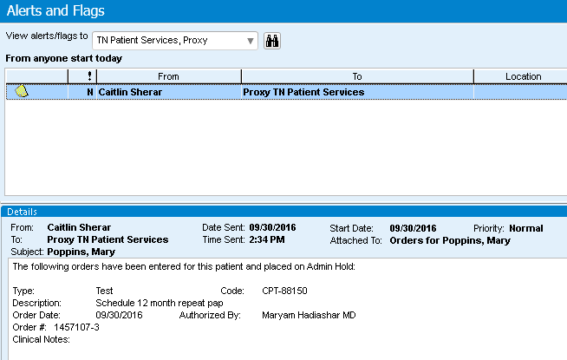

1

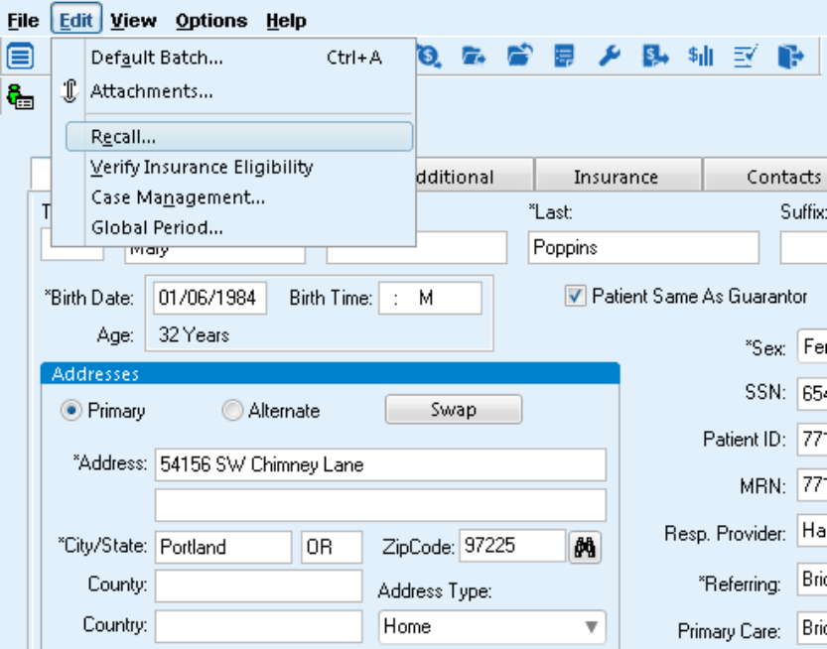
2
3

1. A flag is sent to the Patient Services Proxy when an order for a repeat pap is created. Verify the timing of the repeat pap order (ex: 3 months, 6 months, 12 months)
2. In the patient’s registration click on ‘Edit’, located at the top of the screen
3. Click on ‘Recall’

4

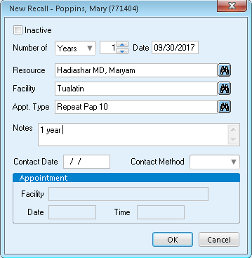
5

6

7

4. Click on ‘New’
5. Change the ‘Number of’ to correspond with the repeat pap order (Ex: 1 year, 6 months, etc.)
6. Document in the notes of the recall what the order timeline is (Ex: 1 year, 6 months, etc.)
7. Click ‘OK’

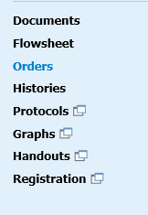
8

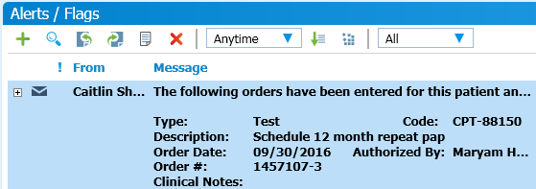
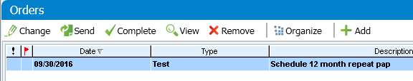
9

10

8. In the patient’s chart, click on ‘Orders’ on the left-hand side of the screen
9. Click ‘Complete’ to complete the order
10. Remove the flag from the Patient Services Proxy

Lab Recalls are made for the Depo Provera shots and the HPV series. The Depo shot recall should be created for 12 weeks from the most recent shot. An additional recall should be created for another following 12 weeks (24 weeks from the most recent shot). The HPV is a three shot series. The second shot should be 2 months after the first shot and the third shot should be 6 months after the first shot. A recall needs to be created for both shots. Indicate in the notes of a lab recall what the recall is for (ex. Depo, HPV #2, HPV #3).
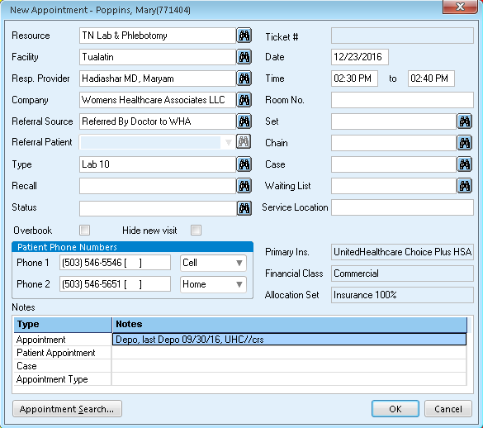

1

2

1. Click on the binoculars
2. Click on ‘New’

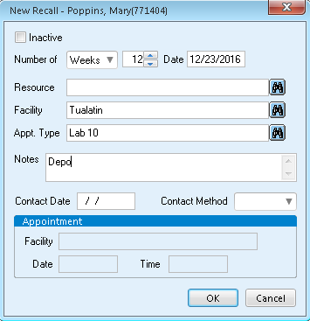
3

4

5
6
7

3. Change the ‘Number of’ to the correct timing (12 weeks for the next Depo, 2 months for the HPV #2 and 6 months for the HPV #3
4. Document in the recall notes what the recall is for (Ex: Depo, HPV #2, etc.)
5. Click ‘OK’
6. In the patient’s registration create a second recall the following lab (Ex: depo or HPV #3) by clicking on ‘Edit’
7. Click on ‘Recall’

7

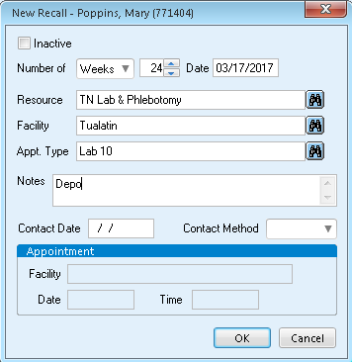
9
12
7. Click ‘New’
8. Change the ‘Number of’ to the needed amount of time (Ex. 24 weeks for the following depo or 6 months for the HPV #3)
9. Change the ‘Resource’ to your clinic’s Lab or Phlebotomy
10. Make the ‘Appt Type’ Lab 10
11. Documents in the notes what the recall is for
12. Click ‘OK’
11
10
8
Scheduling (Continued)
Recalls are created for the following appointments:
Type of Recall |  | Due Date of Recall | Who Makes the Recall
Annual | One year from last annual |  |  | PAS when billing or Reception when scheduling
Mammogram | One year from last mammogram |  |  | PAS when billing/Reception when scheduling
Repeat Pap | Middle of the month due (see order) |  |  | PSR/Reception from orders or when scheduling
Procedure  (Colpos, LEEP, Cryotherapy) | 8 weeks from date being created |  |  | PSR/Reception from orders or when scheduling
HPV Injection | 2 months and 6 months from first injection |  |  | Reception when scheduling second injection
Depo Injection | 12 weeks from last injection |  |  | Reception when scheduling-make two
OB Workup | Patient’s due date |  |  | OB Coordinator
OB Records to L&D ##wk | When records should be sent |  |  | OB Corrdinator (OC only??)

Recall Quiz:

Create a recall for any _________ Annual or _________ Mammogram that does not have one.
If the patient is due for her annual/mammo in the past, create the recall for __________ date (you cannot create a recall for the _____).
If the patient is due for her annual/mammo in the future and there is no recall created, create a recall for the date that she is ____.

Create a recall for Repeat Paps according to ______ (Ex. 3mo, 6mo or 12mo repeat pap).

Create a recall for Procedures (Colpos, LEEPs, Cryotherapy). ‘Appt Type’ = Procedure.
Indicate in the notes of the recall which procedure the recall is for (Ex. Colpo, LEEP, Cryotherapy).
Set the recall to be __ weeks out from _____ (the day you are scheduling the appt, not from the day that the patient is scheduled).

Create a recall for HPV Injections. The ‘Appointment Type’ of the recall = _______.
Indicate in the ____ of the recall which Lab the recall is for (Ex. HPV 2, HPV 3).
The HPV 2 injection should be created for 2 ______ from the first injection.
The HPV 3 injection should be created for __ months from the first injection.

Create a recall for each Depo Injection. The ‘Appointment Type’ of the recall = ______.
Indicate in the notes of the recall which Lab the recall is for (Depo).
The recall needs to be created for ___ weeks from the last injection.
When scheduling the patient for her next appointment, create a recall for the next ___ injections.
Scheduling (Continued)

Appointment Search:
*This feature allows you to search for the next available appointments for a provider.
1
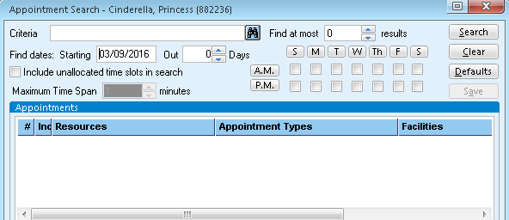
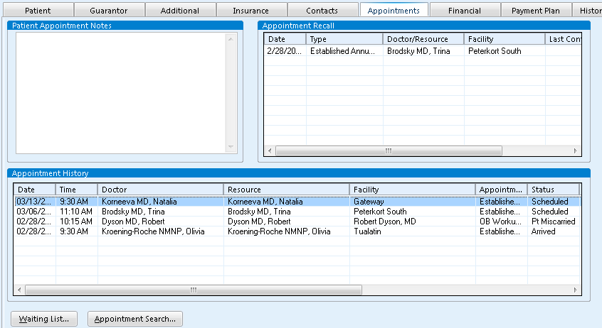
3
2

1. Click ‘Appointment Search’
2. Enter clinician’s last name
3. Click the binoculars

Scheduling/Appointment Search (Continued)
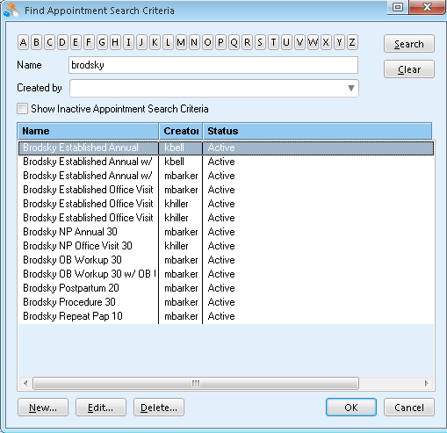

4

5

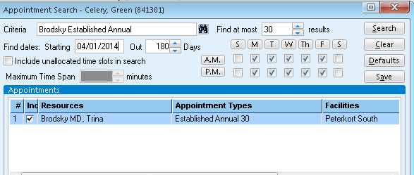
8
7
6

4. A list of all possible appointment types for this clinician will be listed. Choose the one that best suits your needs by highlighting it
5. Click ‘OK’
6. Enter the date you want to begin searching
7. If the patient has specific days or times that will or won’t work, you can uncheck corresponding boxes
8. Click ‘Search’

Scheduling /Appointment Search (continued)

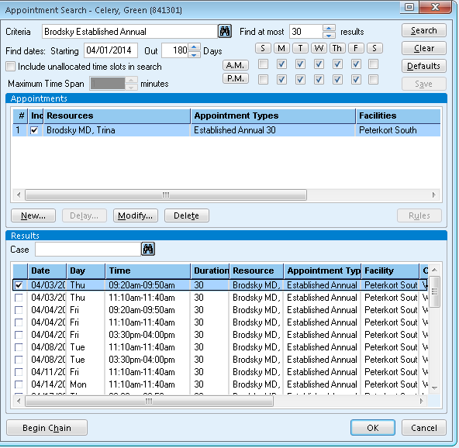

9

9. A list of available appointments will be shown. Check the box next to the appointment you want, and then double click on it
a. Please check the actual schedule to make sure the time will work. Appointment Search does not look to see what you are actually scheduling around, or if part of the allocated spot has for some reason been already scheduled over.

Scheduling /Appointment Search (continued)
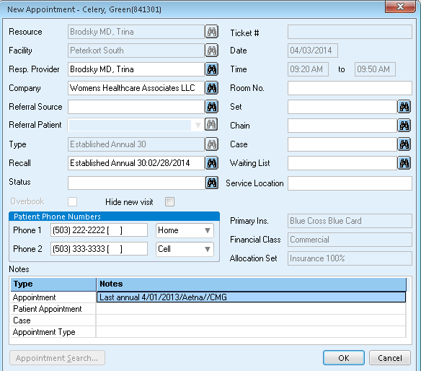
10. Complete the “New Appointment” box as usual
a. ‘Type’ will be automatically filled in
11. Attach a recall if appropriate for the appointment type
12. Put in the appointment notes
13. Click ‘OK’

10
11
12
13

Canceling Appointments:
When a patient cancels her appointment with more than 24 hour notice:
*From the “Appointments” tab in patient’s registration:
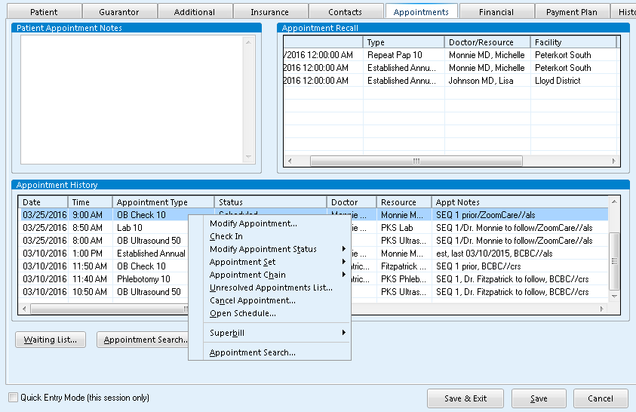
2
1

1. Right click on the appointment that needs to be canceled
2. Click on ‘Cancel Appointment’

Canceling an Appointment (Continued)
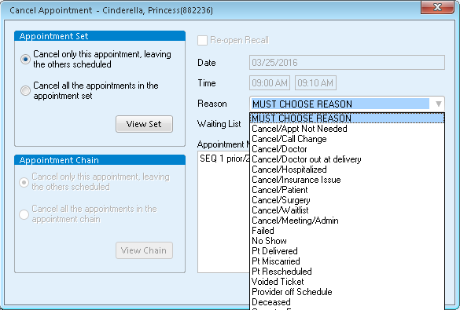

3

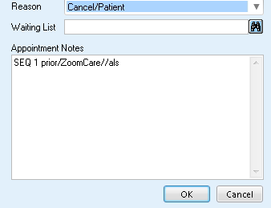

4
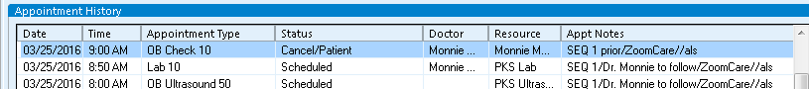
5
3. From the “Reason” drop down, choose the cancelation reason
4. Click ‘OK’
5. The ‘Status’ shows that the appointment has been canceled
*** If the appointment being canceled is one that has a recall attached to it, be sure to modify the appointment first by removing the recall from the appointment. Then cancel the appointment following steps 1-4

Scheduling (Continued)

No Shows:
*A No Show is when the patient missed her appointment without giving notice, or call after the appointment time has passed to cancel.
** When a patient no shows their appointment, a phone note needs to be created and routed to the appropriate proxy (determined by clinic). You will need to do this before No Showing the appointment.
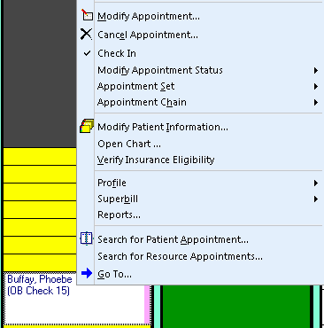

1

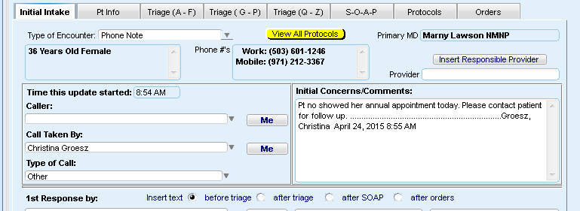

2

1. Right click on the patient’s appointment and choose “Open Chart”
2. Follow the steps laid out in the EMR/Phone Notes section on initiating a phone note.
*In the Initial Concerns/Comments box:
“Pt no showed her “type of appointment” today. Please contact patient for follow up.”

Canceling Appointments/No Shows (Continued)
*After you have created the phone note, you must then cancel the appointment. From the patient’s scheduled appointment:
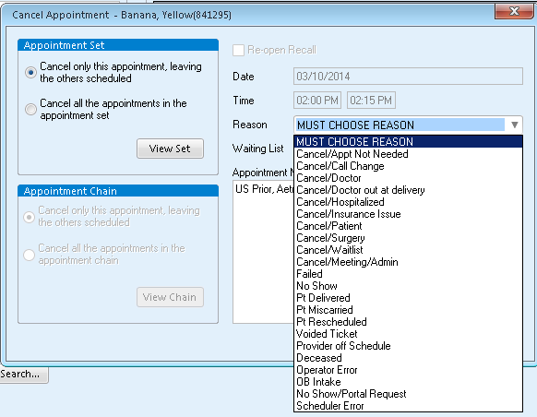
4

5
3

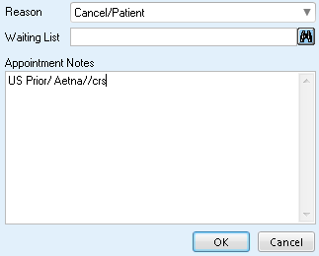

6
3. Right click on the appointment.
4. Left click on ‘Cancel Appointment’
5. From the ‘Reason’ drop down, choose ‘No Show’
6. Click ‘OK’

Failed Appointments:
*A failed appointment is when the patient cancels less than 24 hours prior to appointment.
2

1

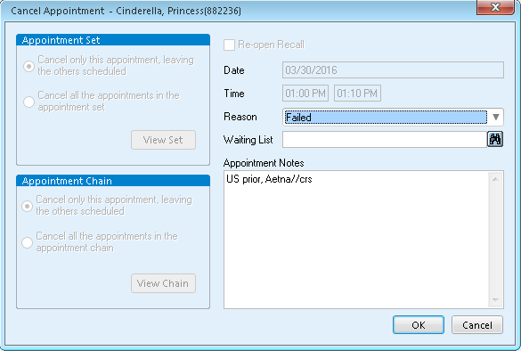

3
4

1. Right click on the appointment that needs to be canceled either from the schedule or the patient’s registration as shown in pages 32-33
2. Click on ‘Cancel Appointment’
3.Choose ‘Failed’ from the drop-down menu for ‘Reason’,
4. Click ‘OK”

Wait List:
*A patient is on a Wait List if the appointment she has is not her ideal time. She is keeping her appointment, but is waiting for a more compatible appointment.
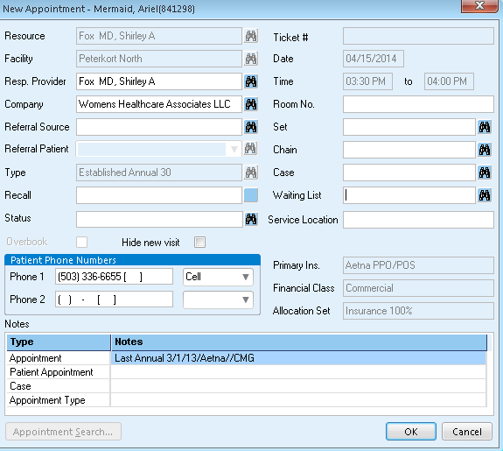

1

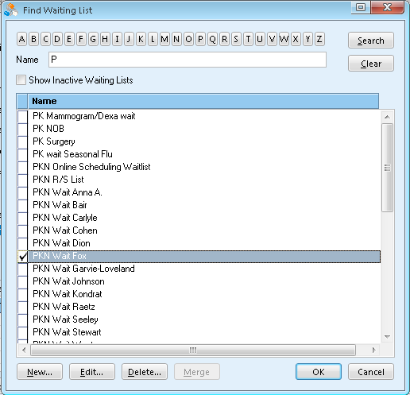
2

3

4

1. From the ‘New Appointment’ box, click the binoculars next to ‘Waiting List’
2. Click on the first letter of the clinic for the provider who’s waitlist the patient will be going on
3. Check-mark the correct provider’s waitlist
4. Click ‘OK’

Scheduling/Wait List (Continued)
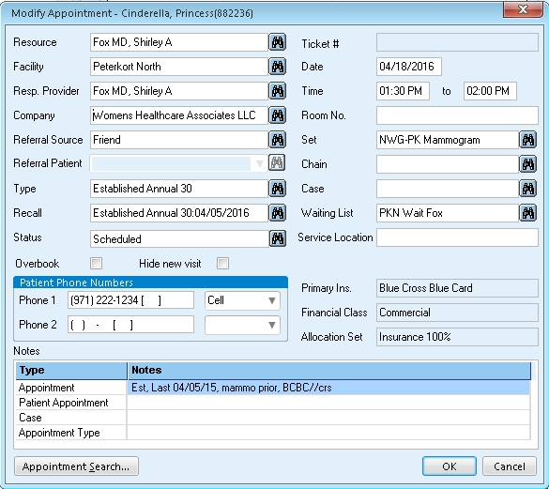

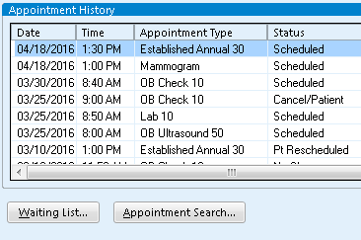
6
5

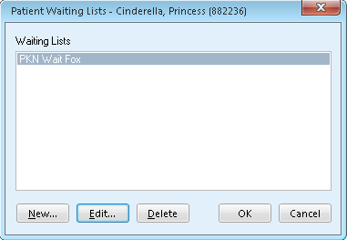

7

5. The appointment is now on the Wait List
6. Click on ‘Waiting List’ to add appointment notes
7. Click ‘Edit’ or double click on waitlist entry you need to add notes to

Scheduling/Waitlist (Continued)
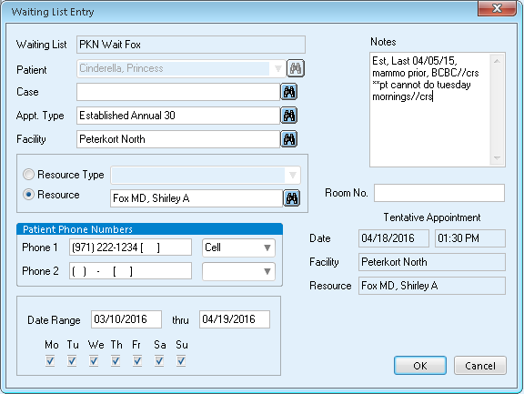
9
8

10

8. Put in the appointment notes for the original appointment
9. Add any additional notes that may be pertinent
10. Click ‘OK’

Reschedule List (Putting a Patient on the r/s List):
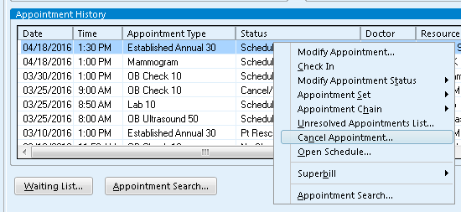
*A patient is on a Reschedule List because WE need her to reschedule. To put a patient on the rescheduled list:
1

2

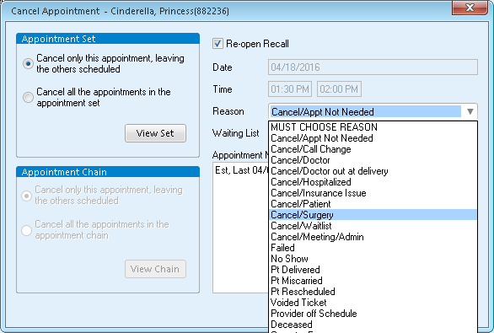
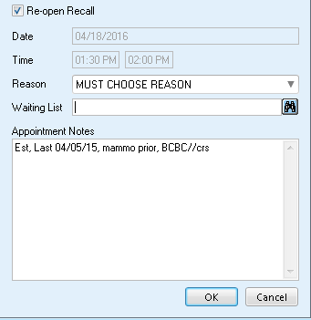
1. Right click on the appointment that needs to be canceled
2. Click on ‘Cancel Appointment’
3. Click the drop-down arrow for ‘Reason
4. Click on the reason the appointment needs to be canceled
5. Click on the binoculars for the ‘Waitling List’

3
4
5
Reschedule List (Continued)
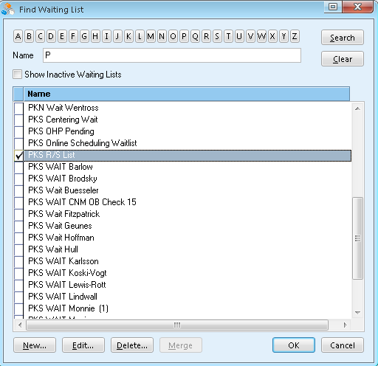
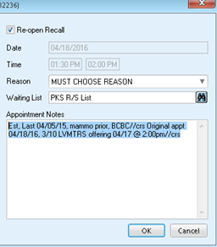
10
9
8
7
6
6. Click on the first letter of your clinic
7. Check-mark the reschedule list for your clinic
8. Click ‘OK’
9. Add notes to the end of the original appointment notes: ‘Original Appt xx/xx/xx, today’s date and actions taken to communicate with the patient if you can’t get a hold of her, any appointments that can be offered to the patient for rescheduling//initials’
a. Highlight and copy all of the notes
10. Click ‘OK'

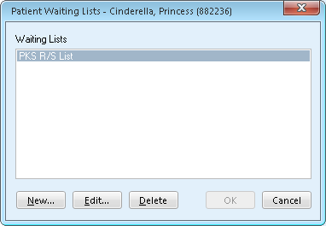
Reschedule List (Continued)
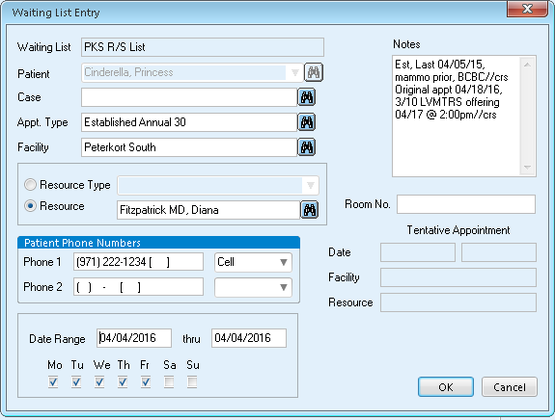
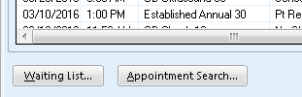
11. Click on ‘Waiting List’ in the ‘Appointments’ tab
12. Click on the reschedule list
13. Click ‘Edit’
14. Paste the appointment and added notes
15. Change the date range to be two weeks prior to the original appointment so that it shows up as important to contact her again in a timely manner
16. Click ‘OK’

15
16
14
13
12
11

Scheduling a Patient from the Reschedule List:

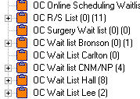
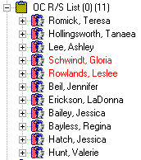
1
2

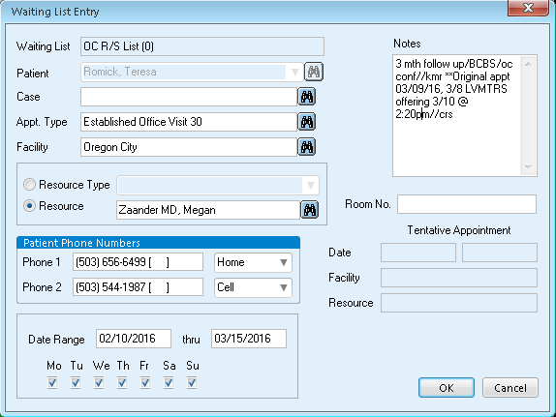
3

4
1. Find your clinic’s reschedule list on the left-hand side of any schedule. Click the + sign to expand the list and see all of the patient’s on the reschedule list
2. Double click on the patient that you are going to reschedule
3. Review the appointment notes, it should tell you when the patient was originally scheduled, what contact efforts have been made and when to reschedule her
4. Click ‘OK’

Reschedule List (Continued)
6
5
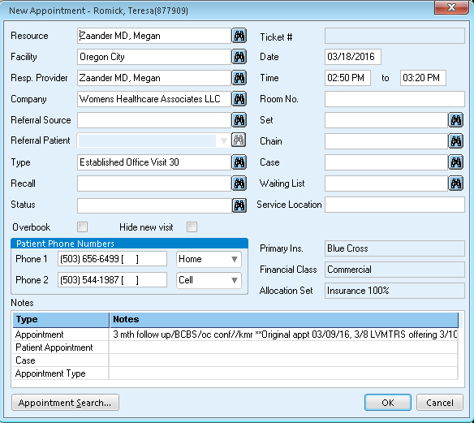
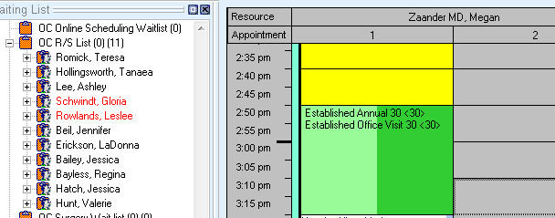

7

5. Click once and hold on the patient’s name
6. Drag and drop the patient’s name to the new appointment time
7. Double clikc on the appointment notes

Reschedule List (Continued)
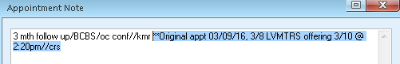
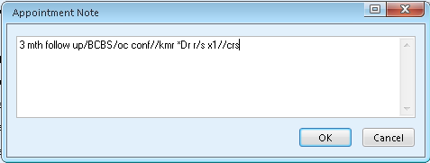
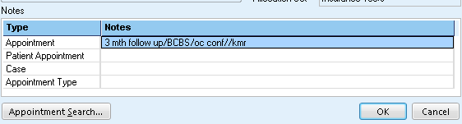
9
8. Delete any notes that no longer apply to the new appointment and add the number of times we have rescheduled the patient
9. Click ‘OK’
10. Click ‘OK’

10
8
Scheduling (Continued)
Finance and Scheduling:
Self pay deposits are as follows:
-For any New GYN pt the deposit is $200
-For any Est GYN pt the deposit is $100 per visit
-For any OB pt who is truly self pay and not pending OHP the deposit is $500 due at the first visit only. After that they should meet with an FC to establish a payment plan.
If a pt has financial aid, the deposit will be different and there will be a note to alert you of this, if there is no note the deposit is as listed above.
Sent to Accelerator:
If a patient has a pop-up note that says, “Sent to Accelerator”, you must check with a financial counselor before scheduling the patient.
Bad Debt:
If you see a note about a bad debt, please inform the pt of the amount and that it MUST be paid prior to being seen (ok to pay at check in). Then note that the patient is aware of the Bad Debt in the appointment notes and a pop-up note in the patient’s registration.
ER Follow Up Appointments:
The only time these payments (self pay deposit/ bad debt) will NOT be required is for a patient coming in for an ER follow up appt. If the patient is self-pay it is still good to let them know they will be financially responsible and to see the FC to discuss a payment plan. For the bad debt notes, please still inform the pt of the balance though it will not be required before an ER follow up visit.
Termed From Care:
If a patient has a note that they are “Termed from Care for Financial”, you CANNOT SCHEDULE the patient until she has paid off the balance. The balance has been sent to a collection agency and is accruing interest. She will need to pay the the collection agency and then they notify us when her balance is paid in full. Only after the Financial Counselor confirms the debt has been paid in full can the patient be scheduled. If the patient has any questions that you are unsure of, transfer her to the Financial Counselor.
Scheduling (Continued)
CNMs and NPs:
*This is a general list. Please check with your clinic to verify each provider’s specific scope of practice.

Can Do | Cannot Do
Annual exams  Birth control  Vaginal infections  STD check (checks and treatment)  Bladder infections  Menopause related visits  Vaginal warts  Infertility workup  OB related visits (CNM only)  HRT  Vulvar biopsies  Menstruation issues  Breast lumps (scheduled through advice)  Abnormal bleeding  IUD insertion and removal | Colposcopies  D&C  LEEP  Cryotherapy  Surgery  Endometriosis  Fibroids  Pessary  Post-op  NPs: No OB related care* (For Extended Hours providers)

Notes: _________________________________________________________________________________________________________________________________________________________________________________________________________________________________________________________________________________________________________________________________________________________________________________________________________________________________________________________________________________________________________________________________________________________________________________________________________________________________________________________________________________________________________________________________________________________

